Institute of Computer Technology

B. Tech Computer Science and Engineering

Subject: ESFP-II (2CSE203)

**PRACTICAL-EXAM**

**1. Implement a program in C++ to access private member through friend modifier.**

***CODE:***

#include <iostream>

using namespace std;

class PracExam

{

private:

    int thread;

    int core;

public:

    void getPCdetails(){

        cout<<"Enter No. Of cores in processor: ";

        cin>>core;

        cout<<"Enter No. Of threads in processor: ";

        cin>>thread;

    }

    friend void showPC(PracExam);

};

void showPC(PracExam P){

    cout<<"\nNo. of cores are "<<P.core<<endl;

    cout<<"No. of threads are "<<P.thread<<endl;

}

int main(){

    PracExam obj;

    obj.getPCdetails();

    showPC(obj);

    return 0;

}

***OUTPUT:***

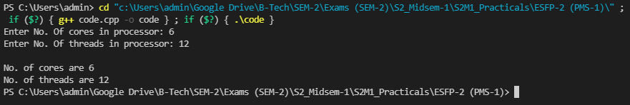

**2. Implement a program in C++ to implement multilevel inheritance for classes India, Gujrat and Gandhinagar.**

***CODE:***

#include <iostream>

using namespace std;

class India

{

public:

void india(){

cout<<"I live in INDIA"<<endl;

}

};

class Gujarat:public India{

public:

void Guj(){

cout<<"I live in GUJARAT"<<endl;

}

};

class Gandhinagar:public Gujarat{

public:

void gandhinagar(){

cout<<"I live in GANDHINAGAR"<<endl;

}

};

int main(){

Gandhinagar G;

G.india();

G.Guj();

G.gandhinagar();

return 0;

}

***OUTPUT:***

